

**US Army Corps of Engineers**

**Afghanistan Engineer District**

AED Design Requirements:

Chlorinators

Various Locations, Afghanistan

MARCH 2009

**TABLE OF CONTENTS**

AED DESIGN REQUIREMENTS FOR

CHLORINATORS VARIOUS LOCATIONS, AFGHANISTAN

Section Page

**1. General 1**

**2. Hypochlorinators 1**

**3. Hypochlorinator Operation 2**

**4. As-Builts 2**

Figures

Figure 1. Typical Hypochlorinator Installation 1

Figure 2. Hypochlorinator Paced by a Propeller-Type Water Meter 1

Examples

Example 1. Check Adequacy of Hypochlorinator 2

**1. General**

The purpose of this document is to provide requirements to Contractors for any project requiring chlorinator design and construction.

**2. Hypochlorinators**

A hypochlorinator is a piece of equipment used to feed liquid chlorine (bleach) solutions. Hypochlorinators used on small water systems are very simple and relatively easy to install. Typical installations are shown in figures below. Hypochlorinator systems usually consist of a chemical solution tank for the hypochlorite, diaphragm-type pump.

Figure 1. Typical Hypochlorinator Installation

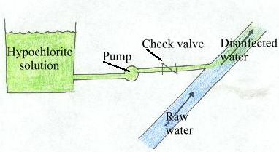

Figure 2. Hypochlorinator Paced by a Propeller-Type Water Meter

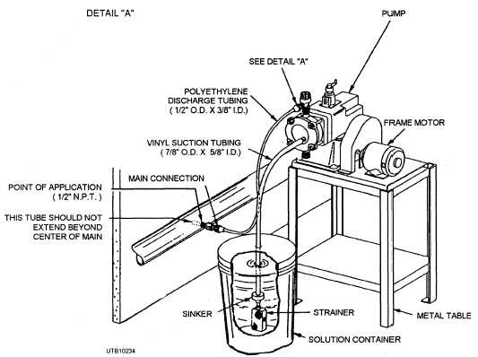

**3. Hypochlorinator Operation**

When operating a hypochlorinator you should compare the actual chlorine dose applied to the water being treated with the desired chlorine dose in milligrams per liter. The actual dose is calculated by determining the amount of chlorine actually used and the amount of water treated. The amount of chlorine used is found by measuring the amount of hypochlorite solution used and knowing the strength of the hypochlorite solution. The amount of water used is determined from a flowmeter.

To calculate the amount of water treated, determine the amount in gallons from a flowmeter and convert this amount from gallons to pounds.

Water, lbs = (Water Treated, gal)(8.34 lbs/gal)

Hypochlorite, gallons = (0.785)(Diameter, ft)2(Depth, ft)(7.48 gal/cu ft)

To determine the pounds of chlorine used to disinfect the water being treated, we have to convert the hypochlorite used from gallons to pounds of chlorine by considering the strength of the hypochlorite solution.

Chlorine, lbs = (Hypochlorite, gal)(8.34 lbs/gal)(Hypochlorite, %/100%)

Finally, to estimate the actual chlorine dose in milligrams of chlorine per liter of water treated, we divide the pounds of chlorine used by the millions of pounds of water treated. Pounds of chlorine per million pounds of water is the same as parts per million or milligrams per liter (ppm=mg/L).

Chlorine Dose, mg/L = Chlorine Used, lbs/Water Treated, Million lbs

**4. As-Builts**

Upon completion of installing the culvert, the Contractor shall submit editable CAD format As-Built drawings. The drawing shall show the final product as it was installed in the field, with the exact dimensions, locations, materials used and any other changes made to the original drawings. Refer to Contract Sections 01335 and 01780A of the specific project for additional details.

**Example 1. Check Adequacy of Hypochlorinator**

Water pumped from a well is disinfected by a hypochlorinator. A chlorine dose of 1.2 mg/L is necessary to maintain adequate chlorine residual throughout the system. During a one-week time period, the water meter indicated that 2,289,000 gallons of water were pumped. A two percent sodium hypochlorite solution is stored in a three-foot diameter plastic tank. During this one-week period, the level of hypochlorite in the tank dropped 2 feet 8 inches (2.67 feet). Does the chlorine feed rate appear to be too high, too low, or about OK?

Known:

Desired Chlorine Dose=1.2 mg/L Water Pumped=2,289,000 gal Hypochlorite= 2%

Chemical Tank Diameter= 3 ft

Chemical Drop in Tank= 2.67 ft

Unknown:

Actual Chlorine Dose, mg/L Is Actual Dose OK

1. Calculate the pounds of water disinfected.

Water = (Water Pumped, gallons)(8.34 lbs/gal)

= (2,289,000 gal)(8.34 lbs/gal)

= 19,090,000 lbs

= 19.09 Million lbs

2. Calculate the volume of two percent sodium hypochlorite used in gallons.

Hypochlorite = (0.785)(Diameter, ft)2(Depth, ft)(7.48 gal/cu ft)

= (0.785)(3 ft)2(2.67 ft)(7.48 gal/cu ft)

= 141.1 gallons

3. Determine the pounds of chlorine used to disinfect the water.

Chlorine = (Hypochlorite, gal)(8.34 lbs/gal)(Hypochlorite, %/100%)

= (141.1 gal)(8.34 lbs/gal)(2%/100%)

= 23.5 lbs Chlorine

4. Estimate the chlorine dose.

Chlorine Dose = Chlorine, lbs/Water, Million lbs

= 23.5 lbs Chlorine/19.09 Million lbs Water

= 1.23 mg/L

Since the actual estimated chlorine dose (1.23 mg/L) was similar to the desired dose of 1.2 mg/L, the chlorine feed rate appears OK.